

American International University-Bangladesh (AIUB)
Department of Computer Science
Faculty of Science & Technology (FST)
Smart Accident Detection and Emergency Response System
Semester: Fall 25-26

Group: |  | Section:
SL | Student Name | Student ID
1 | MD.ABIDUL ISLAM | 22-47875-2
2 | MD.AL-AKHIRUZZAMAN DORPAN | 23-52793-2
3 | BIDHAN SARKER | 23-52811-2
4 | SAYMA RAHMAN SHANTA | 22-48132-2
5 | Tauhid Sarkar | 23-52773-2

Table of Contents

1. Project Proposal xx
1.1 Background to the Problem xx
1.2 Selection of Process Model xx
2. Software Requirements Specification (SRS) / PRD xx
2.1 Scopes and Features xx
2.2 User Story Table xx
2.3 Requirements Traceability Matrix xx
2.3.1 Functional Requirements xx
2.3.2 Non-Functional Requirements xx
3. Software Design xx
3.1 System Deisgn xx
3.2 UI Deisgn using Figma xx
4. Git Workflow xx
5. Software Testing xx
6. Conclusion xx

1. PROJECT PROPOSAL

  - Background to the Problem
Road traffic accidents are one of the leading causes of death and serious injury worldwide, particularly in developing countries like Bangladesh. According to national and global statistics, thousands of people lose their lives every year due to delayed accident detection, poor emergency coordination, traffic congestion, and lack of timely medical response. In many cases, accident victims do not receive medical assistance within the “golden hour,” which significantly increases the risk of fatality or permanent disability.
The existing accident response system heavily relies on manual reporting by witnesses or passersby. This approach has several limitations, including delayed reporting, inaccurate location information, lack of severity assessment, and inefficient coordination among emergency services such as hospitals, police, and ambulance providers. In remote or high-speed highway areas, accidents may go unnoticed for a long time, further worsening the situation.
With the rapid growth of urbanization, vehicle density, and smart city initiatives, there is an urgent need for an intelligent, automated, and technology-driven solution to detect accidents in real time and coordinate emergency responses efficiently. Recent advancements in Internet of Things (IoT), Artificial Intelligence (AI), computer vision, and cloud-based software systems provide an excellent opportunity to address this critical issue.
The proposed Smart Accident Detection and Emergency Response System (SADERS) aims to overcome these challenges by integrating vehicle-based IoT sensors, CCTV-based AI video analytics, and centralized web and desktop software platforms. The system automatically detects road accidents, determines their severity, identifies precise GPS locations, and instantly notifies relevant emergency authorities. By reducing response time and improving coordination among hospitals, police, and traffic management units, SADERS seeks to save lives, minimize injuries, and improve overall road safety.

  - Selection of Process Model
- Selected Process Model: Agile (Incremental & Iterative) Process Model
For the development of the Smart Accident Detection and Emergency Response System (SADERS), the Agile Process Model has been selected as the most suitable software development approach.

- Explanation of the Agile Process Model
The Agile Process Model is an iterative and incremental development methodology that focuses on flexibility, continuous feedback, and frequent delivery of functional system components. Instead of developing the entire system at once, Agile divides the project into smaller modules called iterations or sprints. Each sprint goes through the following phases:
- Requirement Analysis – Identify and prioritize features such as IoT sensor integration, AI video detection, alert systems, and dashboards.
- Design – Design system architecture, databases, APIs, and user interfaces for specific modules.
- Development – Implement selected features for the current sprint.
- Testing – Perform unit testing, integration testing, and validation of functionalities.
- Review & Feedback – Evaluate results with stakeholders and gather feedback.
- Deployment & Improvement – Deploy working modules and refine them in future iterations.
Visualization of Agile Model (Textual Representation):
Planning → Design → Development → Testing → Review
↑____________________________________________↓
Continuous Iteration

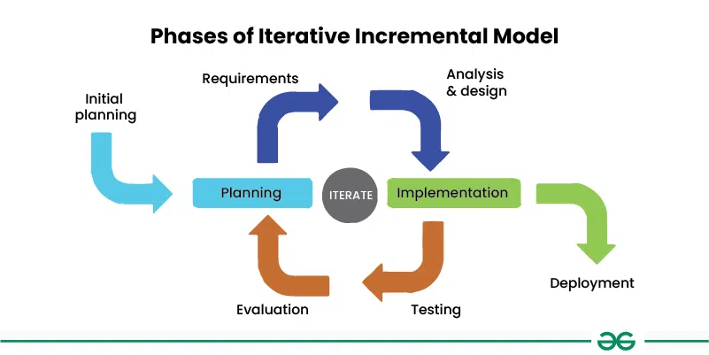
Each cycle produces a working version of the system, gradually adding more features and improvements.
Fig 1: Phases Of Iterative Incremental Model

- Justification for Choosing the Agile Model
The Agile Process Model is chosen for SADERS for the following reasons:
- Complex and Evolving Requirements
SADERS integrates multiple advanced technologies such as IoT sensors, AI-based video analysis, cloud services, APIs, and multi-platform software (web, desktop, mobile). Agile allows continuous refinement of requirements as new insights emerge during development.
- Modular Development
The system consists of independent yet interconnected modules, such as accident detection, alert notification, hospital integration, analytics dashboard, and security management. Agile supports developing these modules incrementally without waiting for the entire system to be completed.
- Frequent Testing and Reliability
Since SADERS is a safety-critical system, frequent testing is essential to ensure accuracy and reliability. Agile promotes continuous testing, reducing the risk of system failure during real-world deployment.
- Stakeholder Feedback and Improvement
Emergency authorities, hospitals, and traffic control operators may provide feedback based on usability and real-time performance. Agile allows incorporating this feedback quickly to improve system effectiveness.
- Scalability and Future Enhancements
Features such as drone integration, AI-based severity estimation, and government system APIs can be added in future sprints without disrupting existing functionalities.
- Faster Delivery of Core Features
Critical components like accident detection and alert dispatch can be delivered early, ensuring partial system usability while advanced features are still under development.

2. SOFTWARE REQUIREMENTS SPECIFICATIONS (SRS) / PRODUCT REQUIREMENTS DOCUMENT (PRD)
2.1 Scopes and Features
The Smart Accident Detection and Emergency Response System (SADERS) is a multi-role, AI + IoT-based emergency management platform. The system scope includes authentication, role-based dashboards, accident detection, emergency response coordination, analytics, and secure data handling.
SADERS System Feature Specification Table (PRD FORMATE )
Feature | Phase | Item No | Screen Name | Screen Definition | User Story / Acceptance Criteria | UI Screen / Wireframe | Acceptance Criteria
Authentication & Authorization | 1 | 1 | Signup | Form with Name, Email, Phone, Password, Re-password, User Type, Signup button, Signin link | Email must be unique, password ≥ 8 chars, passwords must match, user type required, redirect on success | signup | Valid unregistered email only; password ≥ 8 chars; re-password must match; user type required; empty fields show error; credentials saved to DB; confirmation email sent; real-time frontend & backend validation
Authentication & Authorization | 1 | 2 | Signin | Form with Email, Password, Remember Me checkbox, Signin button, Signup & Forgot Password links | Validate email & password, show error on failure, redirect on success | signin | Email must exist; password must match encrypted DB value; error shown on mismatch; redirect on success; remember-me stores secure cookie; brute-force prevention enabled
Authentication & Authorization | 1 | 3 | Forgot Password | Email input, Send Code, Code input, New Password, Confirm Password, Submit | Verify email, send OTP, validate password, show success on reset | forgot_password | Email must exist; OTP sent to registered email; OTP validation required; password ≥ 8 chars with special character; confirm password match; success message shown
Dashboard (Role-Based Control Panel) | 1 | 4 | Admin Dashboard | Table showing total accidents, active alerts, avg response time, live map, graphs | Displays system overview & analytics | dashboard_admin | Shows total accidents & alerts; live map markers; auto-refresh every 30s; loads under 3s
Dashboard (Role-Based Control Panel) | 1 | 5 | Hospital Dashboard | Table with active cases, patient info, severity, ETA, status | Real-time hospital case management | dashboard_hospital | Real-time updates; abnormal detection alerts; AI accuracy >95%; MQTT alerts within 2s; GPS logged
Dashboard (Role-Based Control Panel) | 1 | 6 | Police Dashboard | Table with active incidents, location, severity, patrol status | Incident monitoring & verification | dashboard_police | Alerts include GPS, severity, time; notifications via SMS, push & email; alerts within 5s; logs maintained
Dashboard (Role-Based Control Panel) | 1 | 7 | User Dashboard | My Reports table, Report Accident button, Nearby Incidents map | Manual reporting & SOS | dashboard_user | Shows hospital availability; auto-refresh every minute; role-based access; real-time updates
Accident Detection (IoT + AI Module) | 2 | 8 | IoT Sensor Detection | Sensor data (vibration, speed, GPS), calibrate & test buttons | Detects crash anomalies & sends alerts | iot_detection | Accident markers on map; traffic congestion shown; diversion alerts sent; secure login required
Accident Detection (IoT + AI Module) | 2 | 9 | AI Video Detection | Live CCTV feed with detection overlay | AI-based visual crash detection | ai_video_detection | GPS tracking of responders; ETA shown; updates every 5s; auto/manual unit assignment
Alert & Notification System | 2 | 10 | Automated Alert Dispatch | Recipient, message input, send button | Auto alerts with GPS & severity | alert_system | Valid media required; AI verification; fake report prevention; confirmation on success
Alert & Notification System | 2 | 11 | Notification Tracking | Table of sent alerts with status & timestamp | Alert delivery tracking | alert_log | AI processes images ≤3s; severity prediction ≥90%; logs stored & shared
Hospital Integration Module | 2 | 12 | Hospital Resource Panel | Beds, doctors, ambulance availability table | Live hospital resource tracking | hospital_panel | Region-wise trends; heatmaps; PDF/CSV export; admin-only access
Hospital Integration Module | 2 | 13 | Patient Assignment | Case ID input, hospital dropdown, assign button | Auto assigns nearest hospital | patient_assign | Voice command support; execution ≤2s; visual confirmation; secure by default
Police & Traffic Coordination | 2 | 14 | Traffic Coordination Console | Map with road closures & diversion tools | Traffic control & diversion | traffic_console | Drone auto-dispatch; live feed; secure storage; manual override
Police & Traffic Coordination | 2 | 15 | Patrol Dispatch | Accident ID, patrol unit dropdown, dispatch button | Assigns patrol units | patrol_dispatch | OAuth2/JWT auth; role enforcement; audit logs; encrypted data
Analytics & Reporting | 3 | 16 | Analytics Dashboard | Graphs, heatmaps, charts | Accident trends & risk analysis | analytics_dashboard | Accurate statistics; role-restricted access
Analytics & Reporting | 3 | 17 | Report Generation | Date range, format selector, generate button | PDF/CSV report generation | report_generator | Export supported; secure access
User Application & Citizen Portal | 3 | 18 | Driver Companion App | SOS button, nearby hospitals map, incident list | Emergency assistance app | driver_app | Real-time alerts; hospital info visible
User Application & Citizen Portal | 3 | 19 | Citizen Reporting Portal | Location, image/video upload, description | Citizen-submitted incident reports | citizen_portal | AI authenticity check; fake reports blocked
Security & Data Management | 3 | 20 | Role-Based Access Control | Role-permission table | Secure role management | access_control | JWT/OAuth2 enforced; session timeout
Security & Data Management | 3 | 21 | Data Privacy & Encryption | Encryption toggle module | Data protection & anonymization | data_security | Encryption at rest & transit
Future Enhancements (R&D) | 4 | 22 | Drone Integration | Live drone feed with GPS overlay | Aerial monitoring | drone_module | Secure streaming; linked to accident ID
Future Enhancements (R&D) | 4 | 23 | Voice Command Support | Mic button with listening label | Voice-controlled dashboard | voice_control | Fast execution; secure & limited commands

2.3.2 Non-Functional Requirements
Req ID | Requirement Type | Category | Description | Priority
NFR-01 | Non-Functional | Performance | Accident detection response time shall be ≤ 5 seconds | High
NFR-02 | Non-Functional | Performance | Dashboard data and map refresh rate shall be ≤ 2 seconds | High
NFR-03 | Non-Functional | Security | System shall use JWT / OAuth2-based authentication | High
NFR-04 | Non-Functional | Security | All API and data communication shall be encrypted using HTTPS / TLS | High
NFR-05 | Non-Functional | Reliability | System shall be available 24/7 for emergency operations | High
NFR-06 | Non-Functional | Reliability | Desktop application shall support offline data caching | Medium
NFR-07 | Non-Functional | Scalability | System shall support increasing number of IoT sensors | High
NFR-08 | Non-Functional | Scalability | System shall support expansion to multiple cities and regions | Medium
NFR-09 | Non-Functional | Usability | User interface shall be simple and intuitive | Medium
NFR-10 | Non-Functional | Usability | System shall require minimal training for operators | Medium
NFR-11 | Non-Functional | Maintainability | System shall follow a modular architecture | Medium
NFR-12 | Non-Functional | Maintainability | New features shall be added without interrupting services | Medium
NFR-13 | Non-Functional | Availability | System shall automatically recover from minor failures | High
NFR-14 | Non-Functional | Data Integrity | System shall prevent data loss or duplication | High
NFR-15 | Non-Functional | Compatibility | System shall work on modern browsers and desktop OS | Medium
NFR-16 | Non-Functional | Interoperability | System shall support API integration with hospitals and police | High
NFR-17 | Non-Functional | Accuracy | AI detection shall minimize false positives | High
NFR-18 | Non-Functional | Privacy | Personal and location data shall be anonymized and protected | High
NFR-19 | Non-Functional | Response Coordination | Alerts shall be prioritized based on accident severity | High
NFR-20 | Non-Functional | Logging & Monitoring | System shall maintain detailed logs for auditing | Medium

3. SOFTWARE DESIGN
3.1 System Design:

Use Case Diagram
The Use Case Diagram illustrates the interaction between different users (actors) and the Smart Accident Detection and Emergency Response System (SADERS). The main actors include System Administrator, Police Operator, Hospital Staff, Ambulance Driver, and General User. Each actor performs specific roles such as monitoring accidents, receiving alerts, coordinating emergency responses, and managing system data. The diagram shows all use cases within a system boundary and highlights relationships such as include and extend to represent shared and optional functionalities.

Class Diagram
The Class Diagram represents the static structure of the SADERS system by identifying its main classes and their relationships. Key classes include User, Accident, Sensor, AI_Detection, Notification, Hospital, Police, Ambulance, and Report. Each class contains relevant attributes and operations that define system behavior. Relationships such as associations, aggregations, and compositions are used to show how objects interact and depend on one another, providing a clear overview of the system’s architecture.

Activity Diagram
The Activity Diagram illustrates the overall workflow of the SADERS system from accident detection to emergency response. It begins with accident detection through IoT sensors or AI video analysis, followed by data validation, severity assessment, and alert generation. The workflow then shows parallel activities such as notifying hospitals, police, and ambulance services, ending with response confirmation and data logging. This diagram helps visualize the dynamic flow of processes within the system.

UI / Wireframe Design using Figma
The SADERS wireframes and interactive prototype were developed in Figma based on the functional requirements from the SRS. Each requirement is represented by a corresponding screen or component, ensuring traceability between system functions and the UI.
Key screens—login, accident monitoring dashboard, alert notifications, hospital coordination panel, and reporting interface—were designed following tasks from the Trello user board. Clickable interactions demonstrate user navigation across dashboards, accident details, response coordination, and report generation.
Designs reflect role-based access for administrators, police operators, hospital staff, and emergency responders, consistent with the SRS, Use Case, Class, and Activity Diagrams. Screenshots and the Figma prototype link will be included in the final report to showcase usability and navigation.
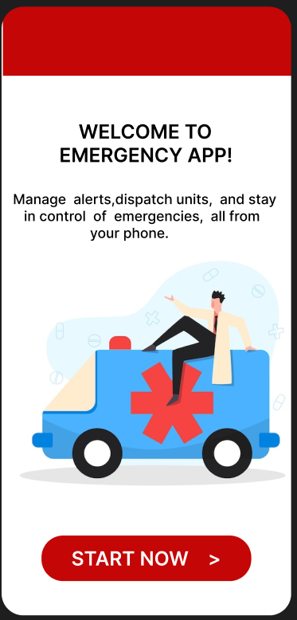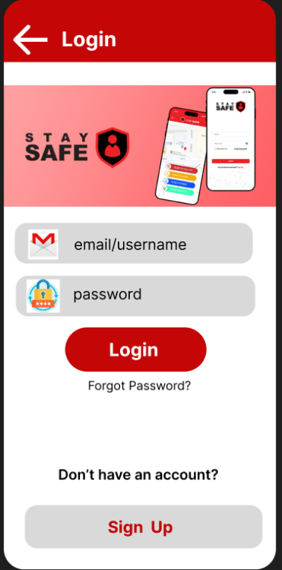

Fig: login page

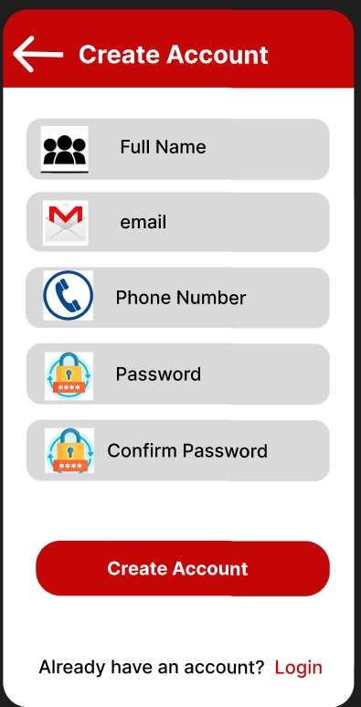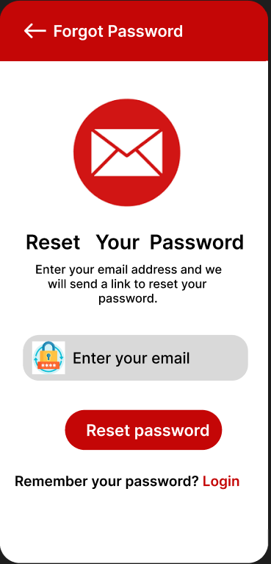
Fig :Signup and Forget password page

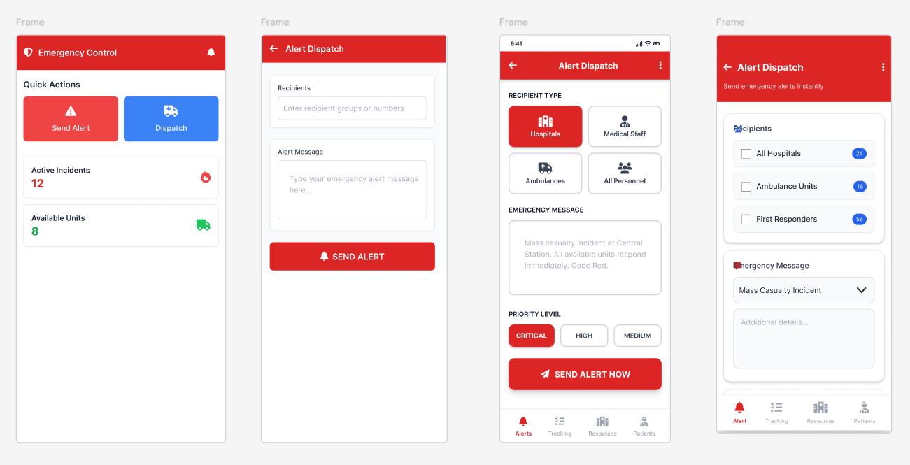
Fig: emergency control and alert dispatch
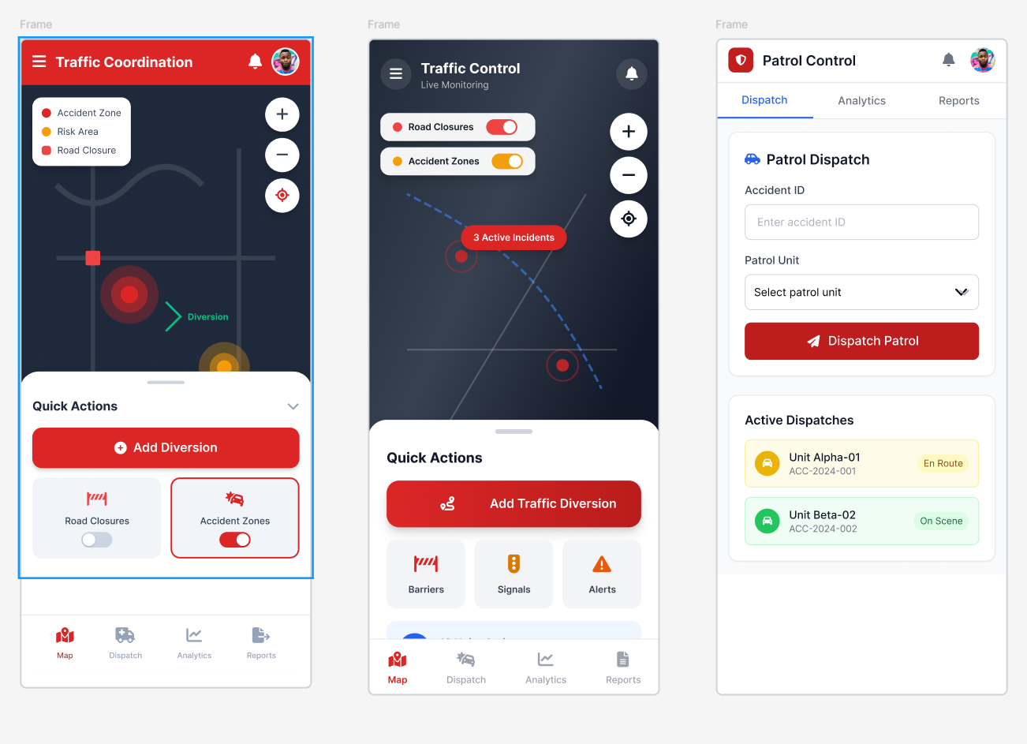

Fig:Traffic and coordination analysis
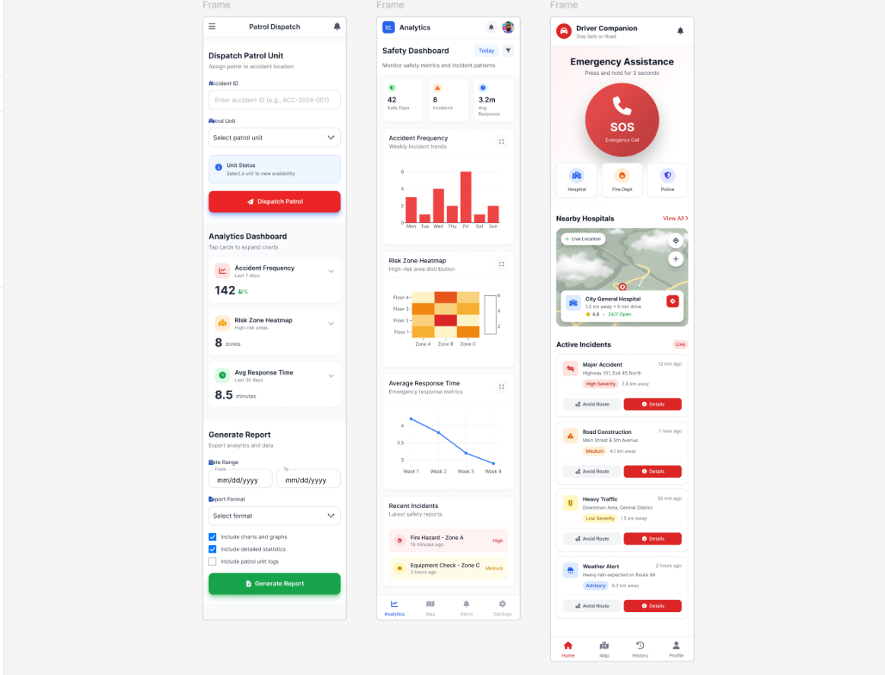
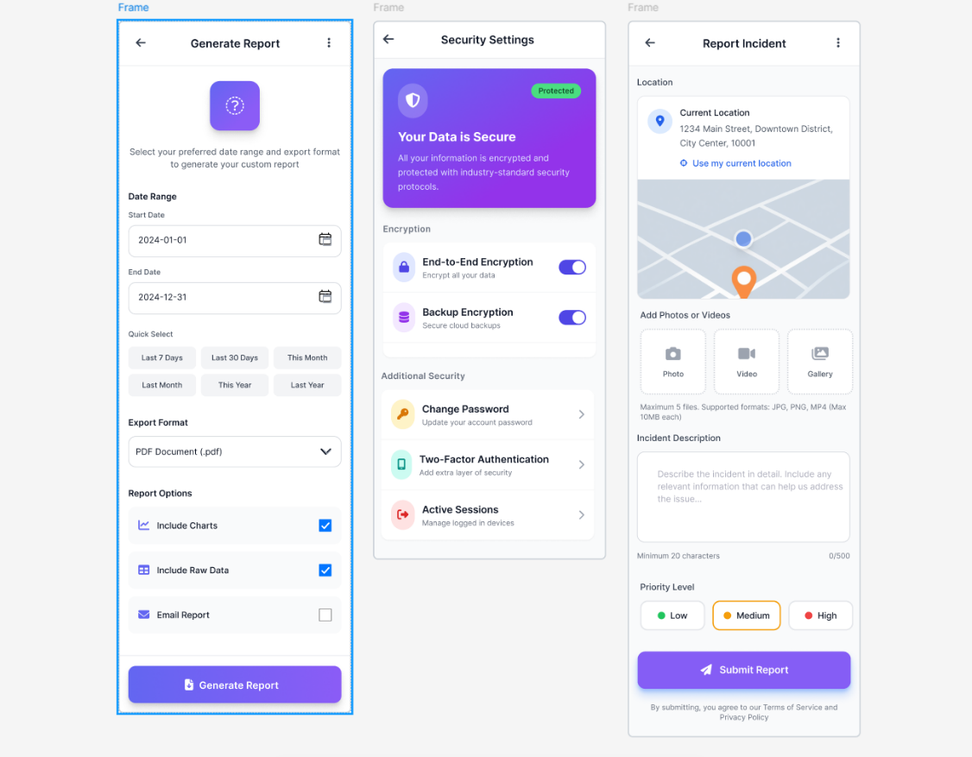
fig: report section
Fig : analysis and emergency assist
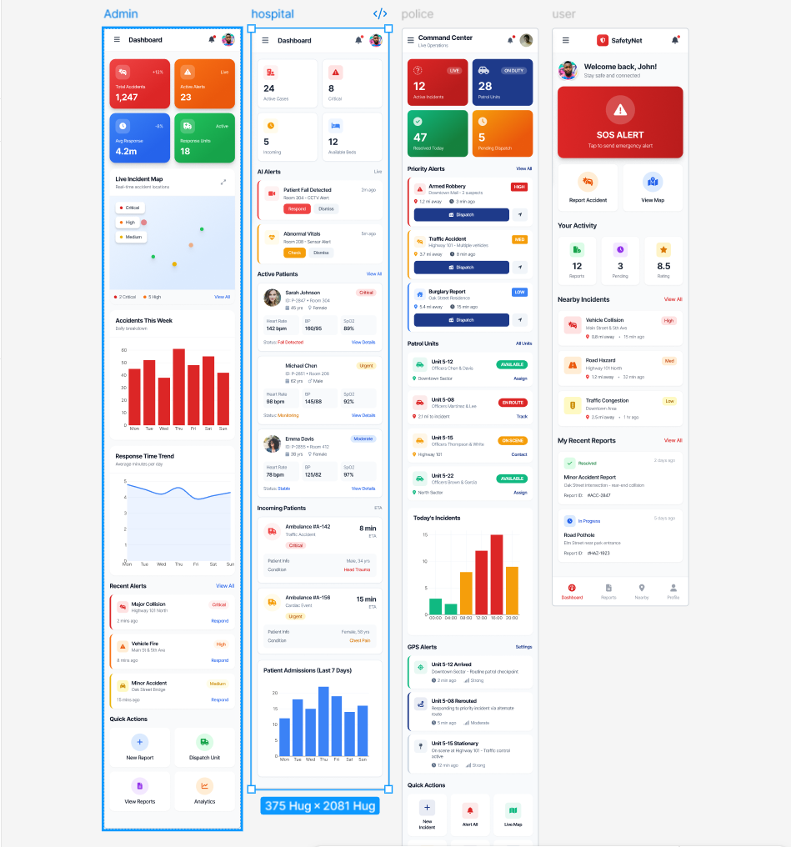
fig: all dashboard
link: https://www.figma.com/proto/lrpCZvZ6ODVNOdEja3iXXA/Untitled?node-id=14-726&t=qnzg0btuEdxDzz5V-1

4. GIT WORKFLOW
Step 1: Create a central repository
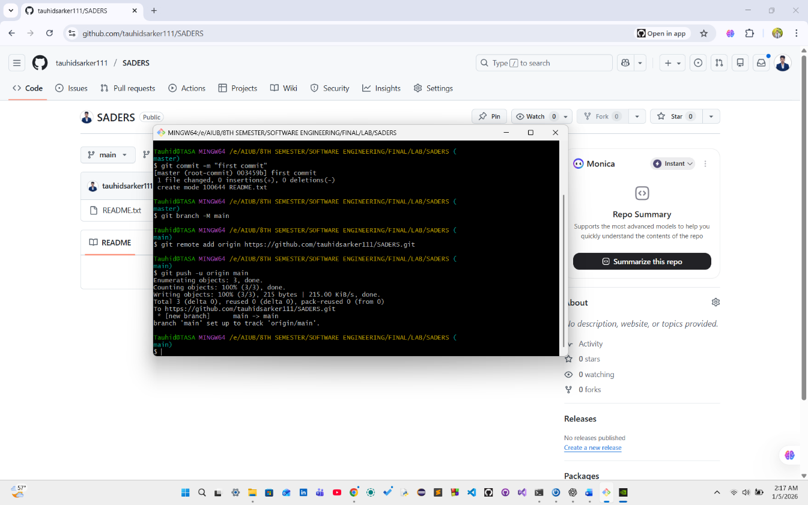
Fig: Push repository

Steps to Create a Project Folder, Initialize Git, and Push to GitHub
- Create a Project Folder
First, create a folder on your local machine for your project. This folder will contain all your project files.
- Initialize Git in the Folder
Open a terminal or command prompt in your project folder and run:
git init
This command initializes a local Git repository in your project folder, enabling version control.
- Stage All Files
Add all your project files to Git’s staging area using:
git add .
The . means all files and subfolders will be included in the next commit.
- Create an Initial Commit
Commit the staged files to the local repository with a message describing the commit:
git commit -m "Initial commit"
This saves a snapshot of your project’s current state.
- Connect to a Remote GitHub Repository
Link your local repository to a GitHub repository you’ve created online:
git remote add origin https://github.com/tauhidsarker01/SADERS.git
Here, origin is the name of the remote, and the URL points to your GitHub repository.
- Push Local Repository to GitHub
Upload your local commits to the main branch of your GitHub repository and set it as the upstream branch:
git push -u origin main
The -u flag sets origin/main as the default remote branch for future pushes, so next time you can simply use git push.
Step 2: Clone the repository
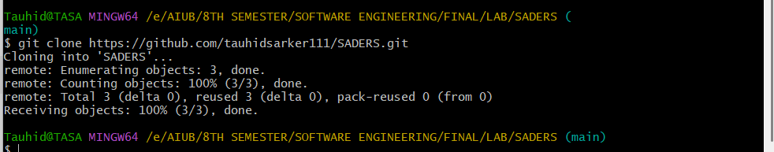

Fig: Clone repository
Each team member needs a copy of the central repository on their own machine. This ensures everyone works with the same code base.
- Clone the Central Repository
Run the following command to copy the repository from GitHub to your local machine:
git clone https://github.com/tauhidsarker111/SADERS.git
This creates a folder named MyProject containing all the project files and the Git history.
- Move into the Project Folder
Navigate into the cloned project directory to start working:Now you are inside the project folder and can start making changes, creating branches, or pulling updates from the central repository.
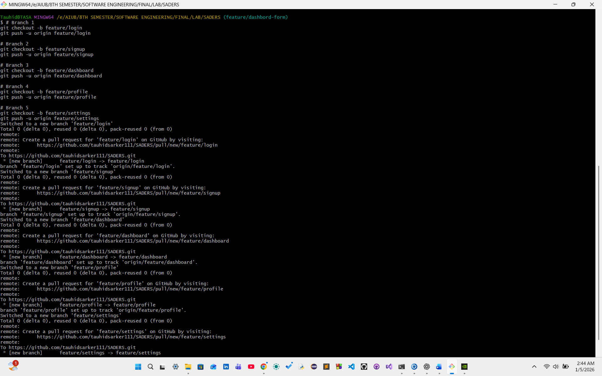
Step 3: Create feature branches

Fig: create branch and push
Who: Each team member, for the tasks assigned to them.
To avoid conflicts and keep work organized, each team member should work on their own feature branch instead of directly on main.
- Create a New Branch for Your Task
Use the following command to create and switch to a new branch:
- git checkout -b feature/<your-feature-name>
Example:
git checkout -b feature/login-form
This creates a branch called feature/login-form and moves you to it.
- Notes:
  - Each member should only work on their own branch.
  - Example branch names: feature/login-form, feature/signup, feature/dashboard, etc.
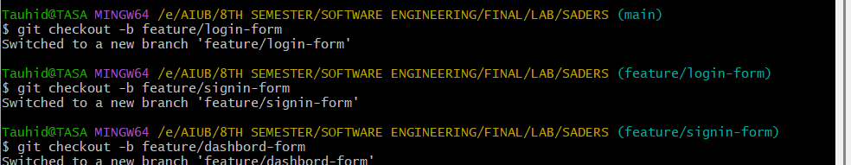
  - This ensures that different features are developed independently without interfering with others.
Fig: switch branch
Step 4: Work on files, stage, and commit changes
Who: Each team member, working on their assigned feature branch.
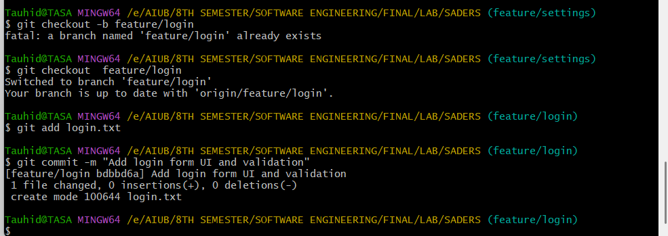
Fig: add or edit file any barch
- Edit or Add Files
  - Work on your feature by editing or creating files.
  - For example, here we are working on login.txt.
- Stage the File for Commit
Tell Git which file you want to include in the next commit:
git add login.txt
  - To stage all modified files at once:
git add .
- Commit Your Changes
Save your staged changes with a clear, descriptive message:
git commit -m "Add login form UI and validation"

- Switch Branches (Optional)
If you need to move to another branch:
git checkout <branch-name>
Or the modern command:
git switch <branch-name>

Step 5: Push Feature Branch to Remote Repository
Who: Each team member, after completing work on their feature branch.
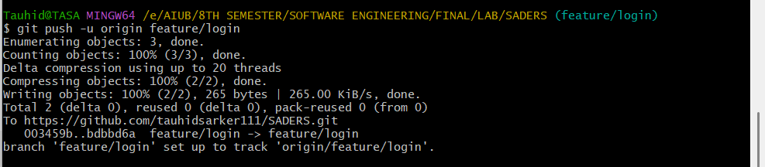
Fig : push in branch
Once you have committed your changes locally, you need to upload your feature branch to GitHub so others can see your work.
- Push Your Feature Branch to GitHub
Use the following command:
git push -u origin feature/<your-feature-name>
Example:
git push -u origin feature/login-form

Step 6: Keep Local Copy Updated
Who: All team members (daily or before starting new work).
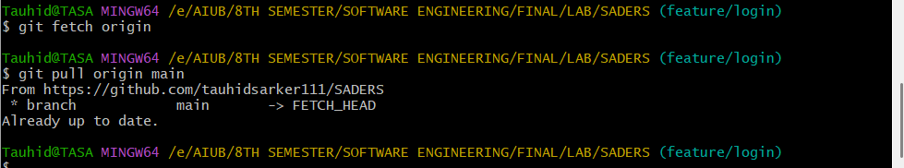
Fig: fetch process
To avoid conflicts and ensure everyone is working with the latest version of the project, you should regularly update your local repository.
- Fetch Updates from the Remote Repository
This command checks for new changes on GitHub without modifying your local files:
git fetch origin
- Pull the Latest Changes from main
Update your current branch with the latest changes from the main branch:
git pull origin main

Step 7: Create Pull Request (PR)
Who: The member who finished their feature
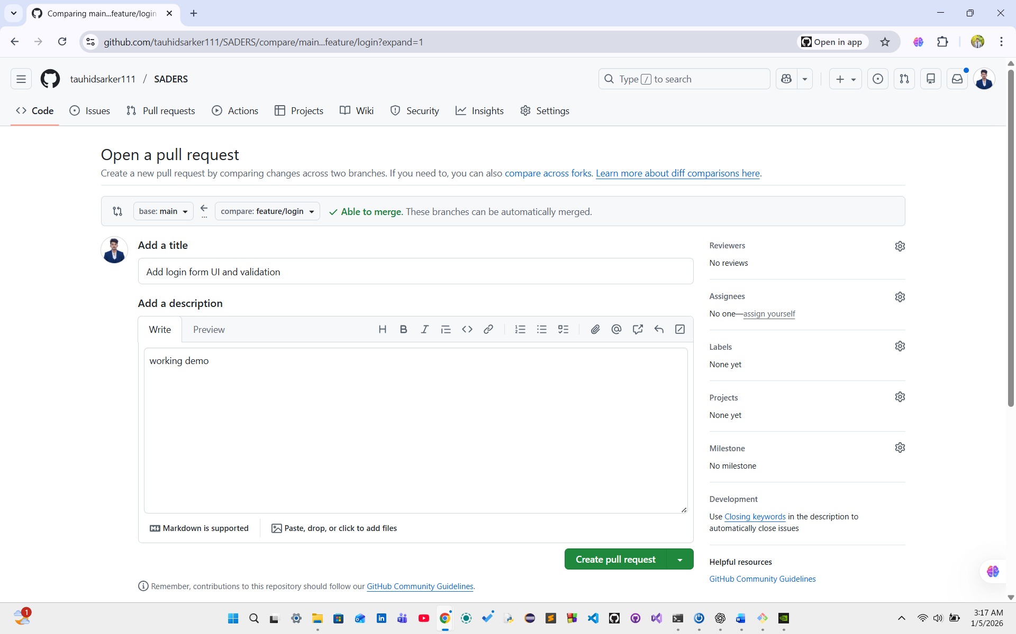
Fig : compare request
- Go to GitHub → your branch → click Compare & Pull Request.
- Assign reviewers (other team members).
- Review code → approve → merge to main branch.

Step 8: Merge Feature Branch into main
Who: After code review and approval (usually the team lead or assigned reviewer).
Once a feature is completed and reviewed, it needs to be merged into the main branch so it becomes part of the final project.

Option 1: Merge on GitHub (Recommended)
- Open a Pull Request (PR) from your feature branch to main on GitHub.
- Review the changes.
- Click Merge to combine the feature branch into main.

Option 2: Merge Locally Using Git Commands
- Switch to the main Branch
git checkout main
- Pull the Latest Updates
git pull origin main
- Merge the Feature Branch
git merge feature/<your-feature-name>
- Resolve Conflicts (If Any)
  - Fix conflicts in the affected files.
  - Stage the resolved files and commit:
  - git add .
  - git commit -m "Resolve merge conflicts"
- Push the Updated main Branch
- git push origin main
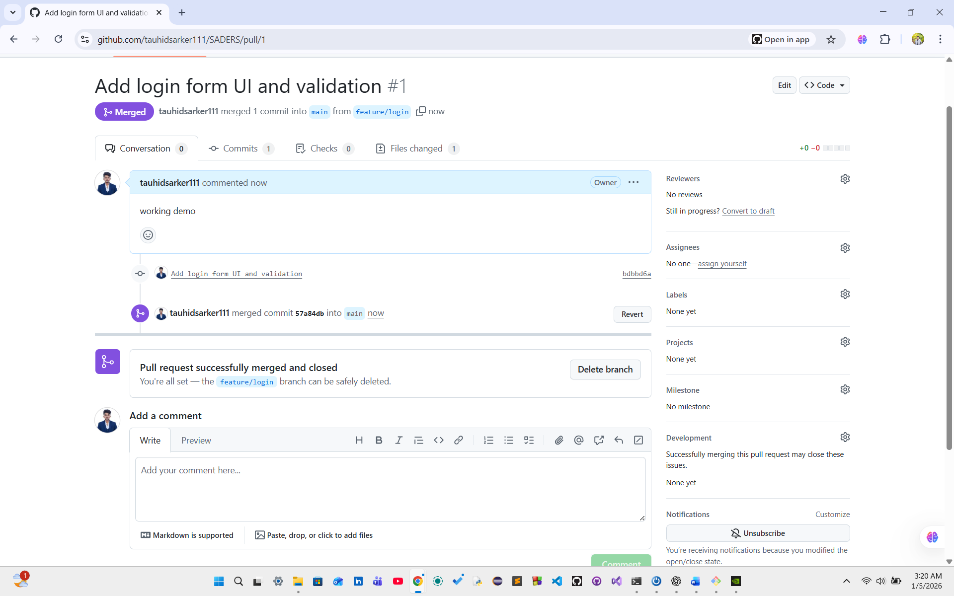
Fig : marge in main branch

Step 9: Delete Feature Branch (Optional)
Who: After the feature branch has been successfully merged into main.
Once your work is merged, the feature branch is no longer needed. Deleting it helps keep the repository clean and organized.

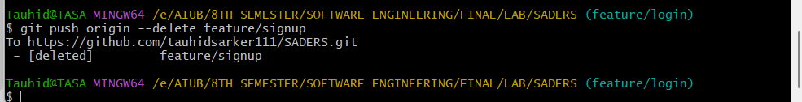
Fig: delete branch
- Delete the Local Feature Branch
Remove the branch from your local machine:
git branch -d feature/<your-feature-name>
- Delete the Remote Feature Branch
Remove the branch from GitHub:
git push origin --delete feature/<your-feature-name>

5. SOFTWARE TESTING
Software testing ensures that the Smart Accident Detection and Emergency Response System (SADERS) works correctly, securely, and reliably under real-world conditions. Since SADERS is a safety-critical system, both functional correctness and system reliability are essential. This section describes the testing approach, strategy, and detailed manual test cases.
5.1 Test Plan

5.1.1 Objective
The objective of testing SADERS is to:
- Verify that all functional requirements work as specified
- Ensure accurate accident detection and alert delivery
- Validate security, performance, and reliability
- Identify and eliminate defects before deployment

5.1.2 Scope of Testing
Testing will cover:
- Authentication and authorization
- Role-based dashboards
- Accident detection (IoT & AI)
- Alert and notification system
- Emergency response coordination
- Analytics and reporting

5.1.3 Test Environment
- Platform: Web & Desktop Application
- Database: Cloud-based (PostgreSQL / Firebase)
- Network: Internet-enabled test network
- Devices: Simulated IoT sensors & CCTV video feeds

5.1.4 Test Deliverables
- Test Plan document
- Manual test cases
- Test execution results
- Bug/defect reports

5.2 Test Strategy
The following testing strategies will be applied:
- Manual Testing
To verify UI interactions such as login, dashboards, alerts, and reports.
- Unit Testing
Individual modules (login, detection, notification) will be tested separately.
- Integration Testing
Ensures smooth communication between IoT devices, AI modules, server, and dashboards.
- System Testing
Tests the entire SADERS system end-to-end.
- Negative Testing
Ensures the system handles invalid input, failures, and unexpected conditions gracefully.
- Performance Testing
Measures system response time during accident detection and alert dispatch.
- Security Testing
Verifies authentication, authorization, and data protection mechanisms.

5.3 Manual Test Cases (Total = 12)
AUTHENTICATION MODULE
- TC-01 (Positive): Valid User Login
Field | Description
Test Case ID | TC-01
Module | Authentication
Preconditions | User is registered
Steps | Enter valid email & password → Click Login
Test Data | admin@saders.com / correct password
Expected Result | User logged in successfully
Status | Pass

- TC-02 (Negative): Invalid Login Credentials
Field | Description
Test Case ID | TC-02
Module | Authentication
Preconditions | User exists
Steps | Enter incorrect password → Click Login
Test Data | admin@saders.com / wrong password
Expected Result | Error message shown
Status | Pass

- TC-03 (Negative): Empty Login Fields
Field | Description
Test Case ID | TC-03
Module | Authentication
Preconditions | None
Steps | Leave fields empty → Click Login
Test Data | Null
Expected Result | Validation warning displayed
Status | Pass

ACCIDENT DETECTION MODULE
- TC-04 (Positive): IoT-Based Accident Detection
Field | Description
Test Case ID | TC-04
Module | IoT Detection
Preconditions | IoT device connected
Steps | Simulate high acceleration
Test Data | Acceleration > threshold
Expected Result | Accident detected
Status | Pass

- TC-05 (Negative): Normal Driving Sensor Data
Field | Description
Test Case ID | TC-05
Module | IoT Detection
Preconditions | IoT active
Steps | Send normal sensor values
Test Data | Normal acceleration
Expected Result | No accident detected
Status | Pass

- TC-06 (Positive): AI CCTV Accident Detection
Field | Description
Test Case ID | TC-06
Module | AI Detection
Preconditions | CCTV feed active
Steps | Analyze crash video
Test Data | Collision video
Expected Result | Accident confirmed
Status | Pass

ALERT & EMERGENCY RESPONSE
- TC-07 (Positive): Automated Alert Dispatch
Field | Description
Test Case ID | TC-07
Module | Notification
Preconditions | Accident detected
Steps | System triggers alert
Test Data | GPS, severity
Expected Result | Alert sent to responders
Status | Pass

- TC-08 (Negative): Network Failure During Alert
Field | Description
Test Case ID | TC-08
Module | Notification
Preconditions | Accident detected
Steps | Disable network
Test Data | —
Expected Result | Alert queued / retried
Status | Pass
- TC-09 (Positive): Ambulance Assignment
Field | Description
Test Case ID | TC-09
Module | Emergency Response
Preconditions | Accident detected
Steps | System assigns ambulance
Test Data | Distance & traffic
Expected Result | Nearest ambulance assigned
Status | Pass

DASHBOARD & REPORTING
- TC-10 (Positive): Admin Dashboard Access
Field | Description
Test Case ID | TC-10
Module | Dashboard
Preconditions | Admin logged in
Steps | Open dashboard
Test Data | —
Expected Result | Dashboard loads correctly
Status | Pass

- TC-11 (Negative): Unauthorized Dashboard Access
Field | Description
Test Case ID | TC-11
Module | Authorization
Preconditions | User logged in as hospital
Steps | Try admin dashboard
Test Data | —
Expected Result | Access denied
Status | Pass
- TC-12 (Positive): Report Generation
Field | Description
Test Case ID | TC-12
Module | Reporting
Preconditions | Accident data exists
Steps | Generate monthly report
Test Data | Date range
Expected Result | PDF/CSV generated
Status | Pass

6. CONCLUSION
The Smart Accident Detection and Emergency Response System (SADERS) is designed to address one of the most critical challenges in modern transportation systems—delayed accident detection and inefficient emergency response. By integrating Internet of Things (IoT) sensors, Artificial Intelligence–based video analytics, and centralized software platforms, SADERS provides a reliable and automated solution for real-time accident monitoring and response coordination. The system significantly reduces human dependency by automatically detecting accidents, identifying precise locations, and instantly notifying relevant emergency authorities.
Through its role-based web and desktop dashboards, SADERS ensures effective communication and coordination among hospitals, police departments, ambulance services, and traffic control units. The inclusion of intelligent ambulance assignments, hospital availability tracking, and traffic management support enhances decision-making during emergency situations. Furthermore, the analytical and reporting features offer valuable insights into accident trends, high-risk zones, and response efficiency, which can support long-term road safety planning and policy development.
Overall, SADERS demonstrates how advanced software engineering combined with AI and IoT technologies can contribute to saving lives, minimizing injuries, and improving public safety. The system is scalable, secure, and adaptable, making it suitable for future enhancements such as drone assistance, predictive analytics, and integration with national emergency services.

